Merchant Care


🎉 Fantastic Work on Completing Day 1 & 2!

You’ve made a great start, and now it’s time to jump into your customized training schedule, tailored to equip you with the skills and confidence needed to support our merchants effectively.

Your Role & Key Objectives

As a Merchant Care representative, your mission is to be the go-to expert for merchants when they encounter issues with:
- The BackOffice system
- The POS App
- Any general inquiries about StoreHub’s products

To do that well, your product knowledge needs to be razor-sharp—and that’s exactly what this next phase of training is all about.

What You’ll Be Mastering

- Advanced Product Knowledge - Dive deep into every feature, function, and flow—so you can troubleshoot like a pro.

- Hardware Troubleshooting - Get hands-on with common tech issues through hardware assessments that test your problem-solving skills.

- Mock Chat Simulation - Practice handling real-life scenarios through simulated chats to test how field-ready you are before going live.

These next few days will challenge you—but they’re designed to shape you into a confident, capable, and merchant-ready support superstar.

How it Works

📌 Follow Your Schedule: Stick to the assigned time slots and topics to stay on track.

📌 Accessing Your Resources: For each topic, make sure to check out the resources provided under your role-specific tabs in the Training Wiki. These materials are your go-to guides to master the skills and knowledge required.

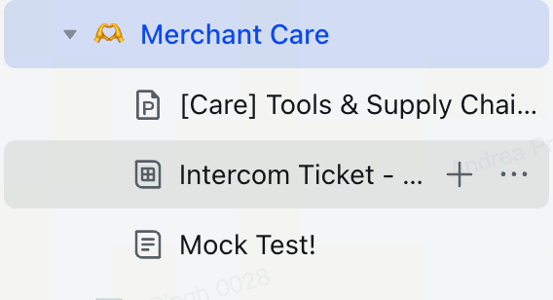

Your Schedule
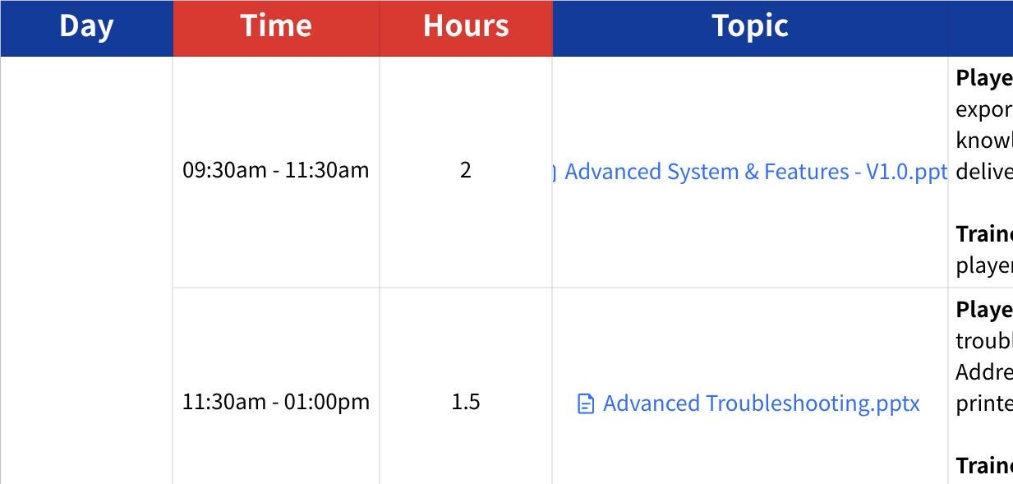
Click the image to view the sheet.

